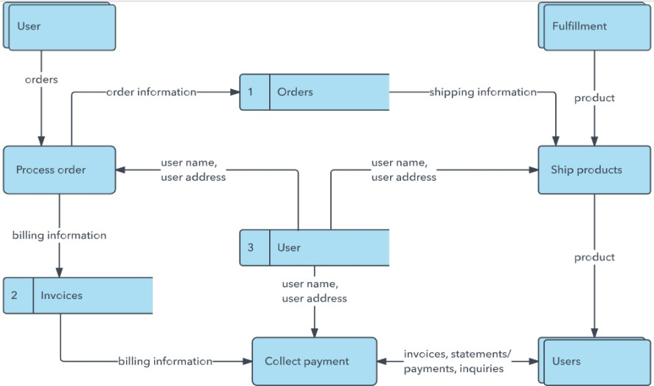
Project Design Phase-II

Data Flow Diagram & User Stories

Date | 27 JUNE 2025
NM ID | 8050612605B5D909A0D43F9BC95E1D9A
Project Name | Garage Management system
Maximum Marks | 4 Marks

Data Flow Diagrams:
A Data Flow Diagram (DFD) is a traditional visual representation of the information flows within a system. A neat and clear DFD can depict the right amount of the system requirement graphically. It shows how data enters and leaves the system, what changes the information, and where data is stored.
In the project "Prevent User Deletion if Assigned to an Incident", Data Flow Diagrams (DFDs) illustrate how user deletion requests are processed within the system. The DFD shows the interaction between the admin, the system, and the incident database to validate whether a user is assigned to any active incidents. If the user is linked to an incident, the system blocks the deletion request to maintain data integrity and accountability.

Example:
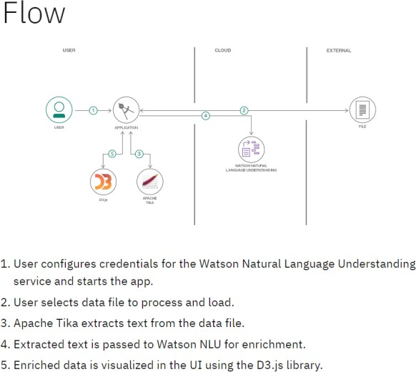

User Stories:
User stories define what different users need from the system in simple, goal-focused language. In this project, they help ensure the system blocks user deletion only when necessary, protecting incident data.

User Type | Functional Requirement (Epic) | User Story Number | User Story / Task | Acceptance criteria | Priority | Release
Administrator | User Management | USN-1 | As an admin, I want to delete a user from the system. | The system should allow deletion only if the user is not assigned to any incident. | High | Sprint-1
System (Auto- check) | Validation before Deletion | USN-2 | As a system, I must check if the user is linked to any incident before processing a delete request. | Deletion proceeds only if no incident is assigned; else, it should be blocked. | High | Sprint-1
Incident Manager | Alert Notification | USN-3 | As an incident manager, I want to receive an alert if a user with assigned incidents is requested for deletion | System shows a warning or alert about linked incidents before deletion. | Medium | Sprint-2

